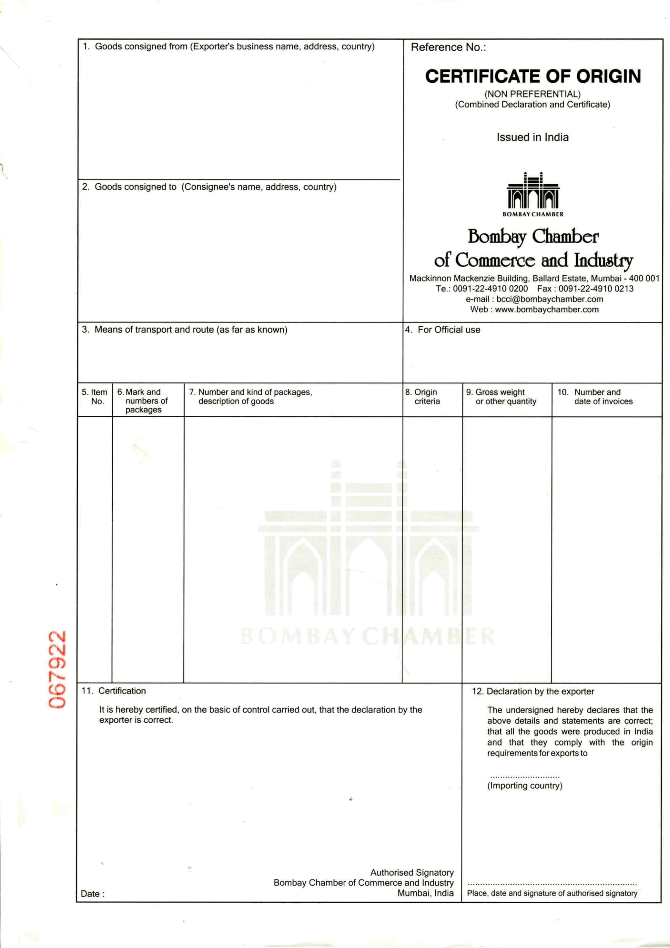
INSECTICIDES INDIA LTD.
PLOT NO. Z/50,
PART - I, DAHEJ-SEZ
TALUKA- VAGRA -392130
DISTRICT- BHARUCH. GUJARAT (INDIA)
GSTIN - 24AAACI3076P2ZA

TOPEX AGRO-ELEVAGE DEVELOPPEMENT COTE
D'IVORE-SARL
TREICHVILLE ZONE 2, 4EME IMMEUBLE RMJ,
SGBCI BOULEVARD DE MARSEILLE,
12 BP 2062, ABIDJAN 12
TEL: +225-21242576/79
CONTACT PERSON ; MR. BRIJESH SHAH

HAZIRA , INDIA TO PORT ABIDJAN, IVORY COAST
VESSEL & VOY : MAERSK KLAIPEDA Voyage No – 035W

COUNTRY 3x40 ft DRY FCL CONTS INDIA GROSS WEIGHT INV.NO. 04 & 05 IVORY COAST 6900 CORRUGATED BOXES ONLY : 75675.00 KG
2400 Corrugated Boxes
ORIGIN INSECTICIDES FOR AGRICULTURE PURPOSE NET WEIGHT : Invoice Dtd: INDIA Acetamiprid 2%+Cypermethrin 2%EC(w/v : 61593.00 KG 21.08.2020
C-BOX. 01-1950 (H.S. CODE NO . 3808.91.99)
BATCH NO. E0013 PACKING: 1 LTR JERRY CAN X 10 NOS = 10 Ltr
Qty : 24000 LTR “WE CERTIFY THAT
C-BOX. 01-450 UN no. : 2903, Class :6.1 Packing Group :III THE GOODS ARE BATCH NO.E0014 INDIAN ORIGIN.”
4500 Corrugated Boxes
C-BOX. 01-4500 INSECTICIDES FOR AGRICULTURE PURPOSE
BATCH NO D0050 LAMBDA CYHALOTHRIN 2.5% EC (W/V)
CONTAINER NO. (H.S. CODE NO : 3808.91.99)
MSKU1757463 (40'ft) PACKING: 1 LTR X 10 PET BOTTLE = 10 Ltr
SUDU8896130 (40'ft) QTY : 45000 LTR
MRKU5772947 (40'ft) UN no. : 3351, Class :6.1 Packing Group :III
SHIPPING LINE SEAL NO
INV NO.: 04/21.08.2020 & 05/21.08.2020
ML-IN2984680 SB NO: 4010292 DATED..21.08.2020
ML-IN2984629 BL NO. 911131607 DATED.25.08.2020
ML-IN2984625 IEC NO: 0501068023 BRANCH NO. 11

IVORY COAST
DATE: 24.08.2020

